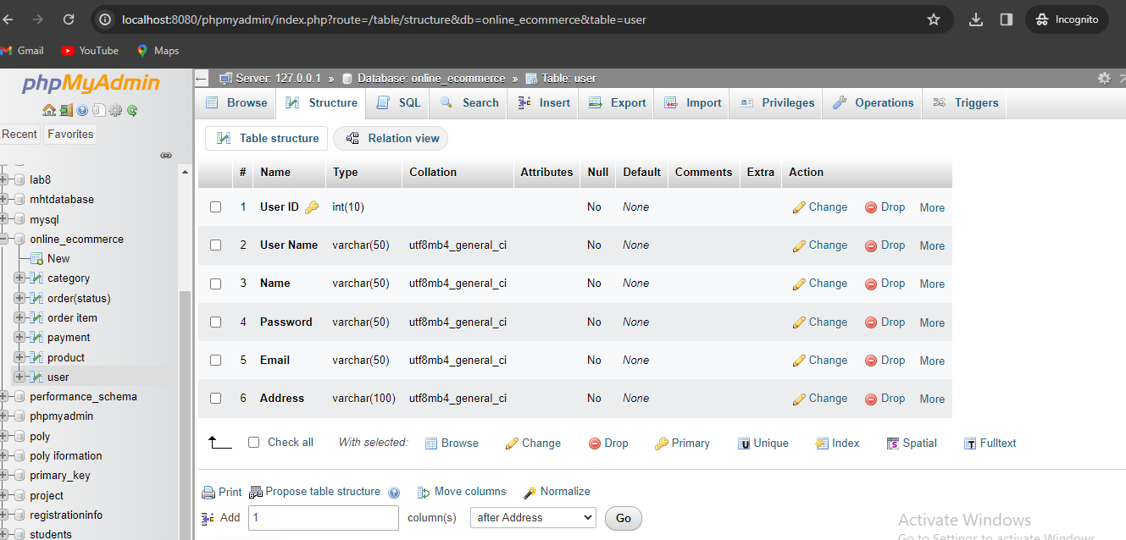

**Figure 02: Database**

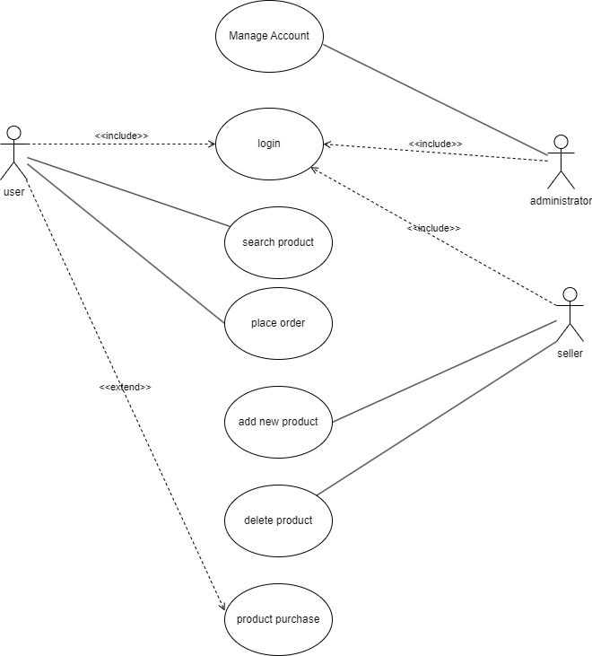

**Figure 03: use case diagram**

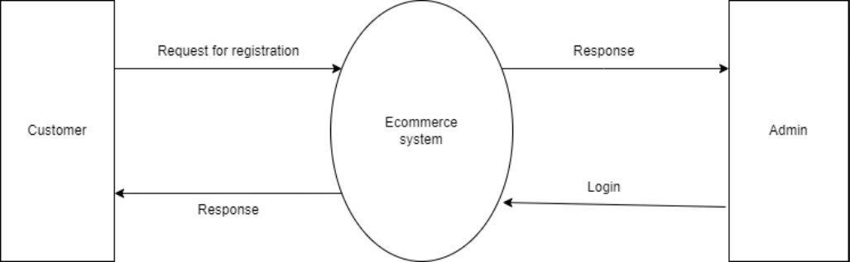

**Figure 04: DFD 0**

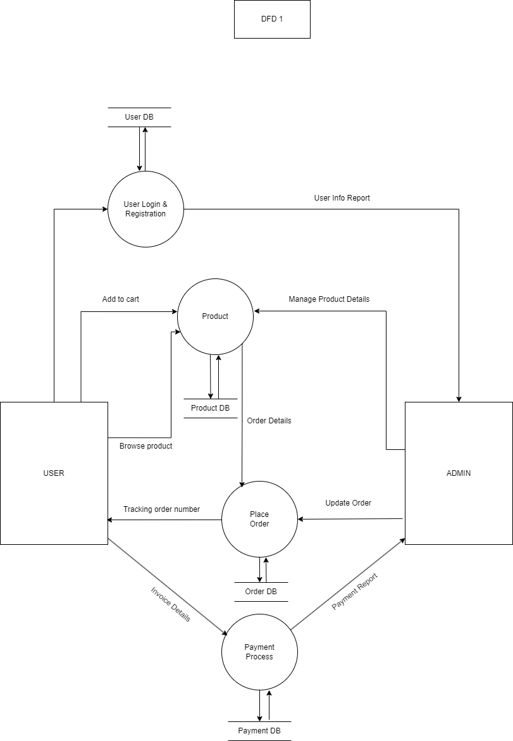

**Figure 05: DFD 1**

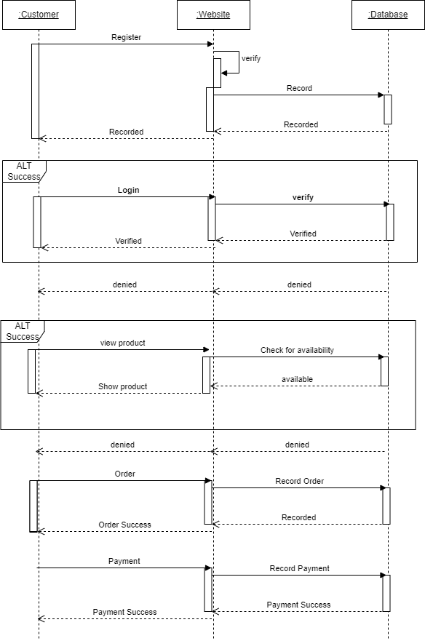

Figure 06: sequence diagram

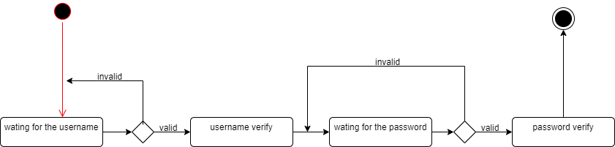

**Figure 07: State diagram 1**

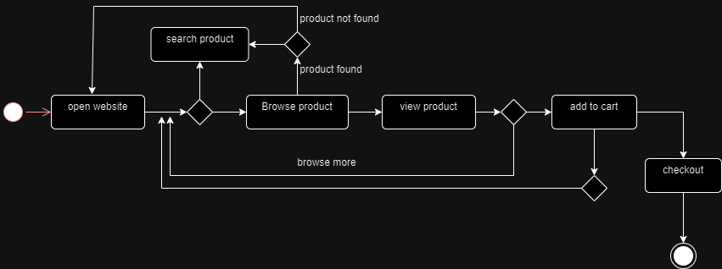

**Figure 08: State diagram 2**

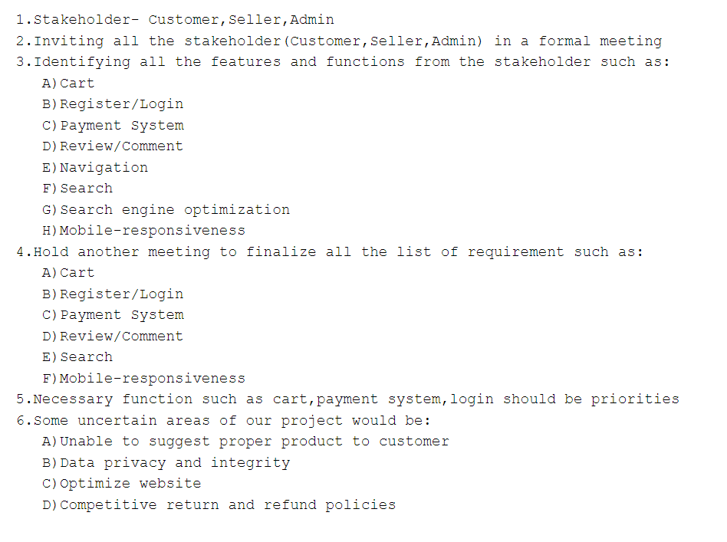

**Figure 09: Task set**

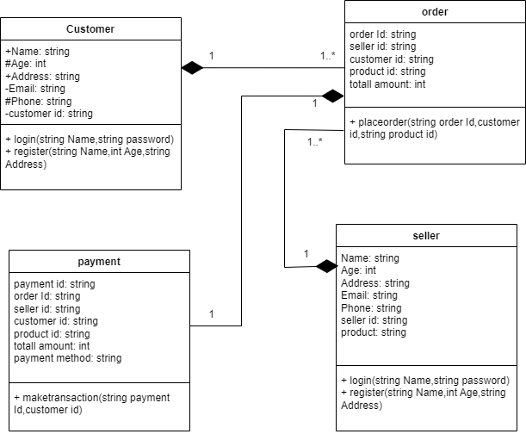

**Figure 10: UML Class diagram**

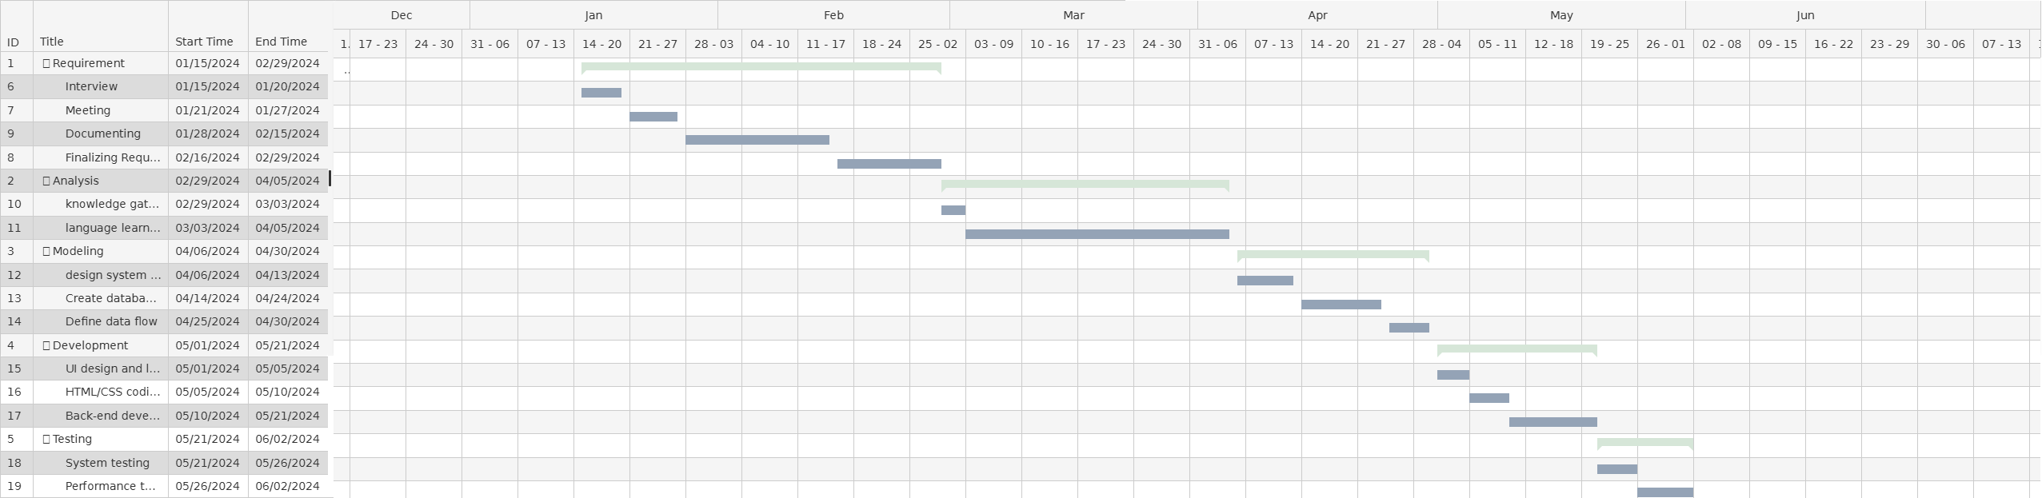

**Figure 11: Gantt Chart**

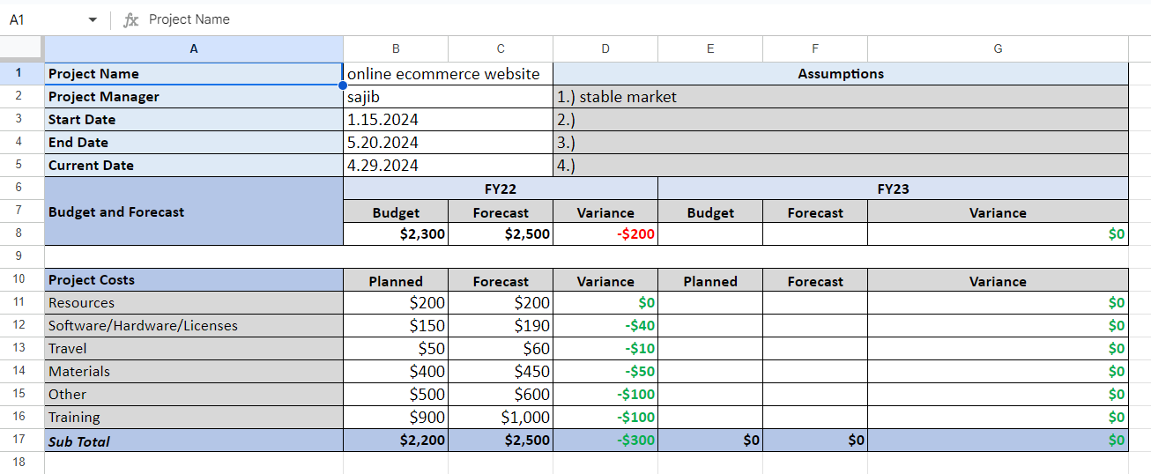

**Figure 12: Budget**